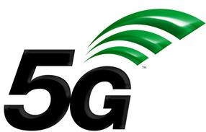**5G**

**Theoretical Laboratory Session**

Wireless Communications 371-1-1903

Spring 2020

# Part 1 – General Theoretical Information

## **5G** **cellular network technology**

**Radio frequencies** - The air interface defined by 3GPP for 5G is known as *New Radio (NR)*, and the specification is subdivided into two frequency bands, **FR1** (below 6 GHz) and **FR2** (mmWave), each with different capabilities:

* **Frequency range 1** (< 6 GHz) - The maximum channel bandwidth defined for FR1 is 100MHz, due to the scarcity of continuous spectrum in this crowded frequency range. The band most widely being used for 5G in this range is around 3.5 GHz.
* **Frequency range 2** (> 24 GHz) - The minimum channel bandwidth defined for FR2 is 50 MHz and the maximum is 400 MHz, with two-channel aggregation supported. 5G can use frequencies of up to 300 GHz. The higher the frequency, the greater the ability to support high data transfer speeds without interfering with other wireless signals or becoming overly cluttered. Due to this, 5G can support approximately 1,000 more devices per meter than 4G.

5G in the 24 GHz range or above signals are not capable of traveling large distances (over a few hundred meters), unlike 4G or lower frequency 5G signals (sub 6 GHz). This requires placing 5G base stations every few hundred meters in order to use higher frequency bands. Also, these higher frequency 5G signals cannot penetrate solid objects easily, such as cars, trees, and walls, because of the nature of these higher frequency electromagnetic waves.

**Massive MIMO** - Massive MIMO (multiple input and multiple output) antennas increases sector throughput and capacity density using large numbers of antennas and Multi-user MIMO (MU-MIMO). Each antenna is individually-controlled and may embed radio transceiver components. The more antennas the transmitter/receiver is equipped with, the more the possible signal paths and the better the performance in terms of data rate and link reliability. The greater number of antennas in a Massive MIMO network will also make it far more resistant to interference and intentional jamming than current systems that only utilize a handful of antennas.

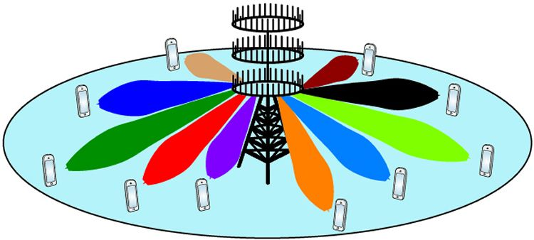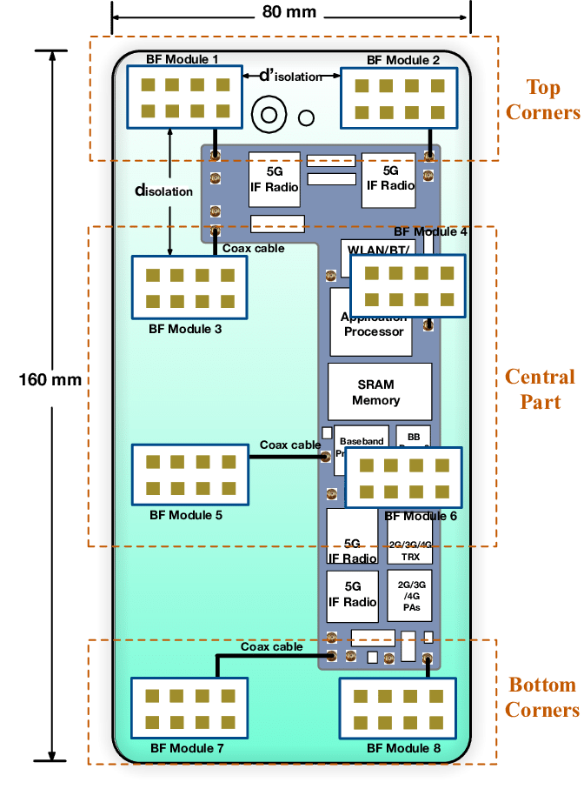

**Multi-access Edge computing -** Edge computing is a network architecture concept that enables cloud computing capabilities and an IT service environment at the edge of the cellular network and, more in general at the edge of any network. The basic idea behind Multi-access Edge computing (MEC) is that by running applications and performing related processing tasks closer to the cellular customer, network congestion is reduced, and applications perform better. MEC technology is designed to be implemented at the cellular base stations or other edge nodes and enables flexible and rapid deployment of new applications and services for customers. Combining elements of information technology and telecommunications networking, MEC also allows cellular operators to open their radio access network (RAN) to authorized third parties, such as application developers and content providers.

**Small cell** - Small cells are low-powered cellular radio access nodes that operate in licensed and unlicensed spectrum that have a range of 10 meters to a few kilometers. Small cells are critical to 5G networks, as 5G's radio waves can't travel long distances, because of 5G's higher frequencies.

**Beamforming** - Beamforming, as the name suggests, is used to direct radio waves to a target. This is achieved by combining elements in an antenna array in such a way that signals at particular angles experience constructive interference while others experience destructive interference. This improves signal quality and data transfer speeds. 5G uses beamforming due to the improved signal quality it provides. Beamforming can be accomplished using Phased array antennas.

**Wifi-cellular convergence** -One expected benefit of the transition to 5G is the convergence of multiple networking functions to achieve cost, power, and complexity reductions. LTE has targeted convergence with Wi-Fi band/technology via various efforts, such as License Assisted Access (LAA; 5G signal in unlicensed frequency bands that are also used by Wi-Fi) and LTE-WLAN Aggregation (LWA; convergence with Wi-Fi Radio), but the differing capabilities of cellular and Wi-Fi have limited the scope of convergence. However, significant improvement in cellular performance specifications in 5G, combined with migration from Distributed Radio Access Network (D-RAN) to Cloud- or Centralized-RAN (C-RAN) and rollout of cellular small cells can potentially narrow the gap between Wi-Fi and cellular networks in dense and indoor deployments. Radio convergence could result in sharing ranging from the aggregation of cellular and Wi-Fi channels to the use of a single silicon device for multiple radio access technologies.

**NOMA (non-orthogonal multiple access)** - NOMA is a proposed multiple-access technique for future cellular systems via allocation of power.

**SDN/NFV (Software-defined networking, SD-WAN, Network function virtualization, and 5G network slicing)** - Initially, cellular mobile communications technologies were designed in the context of providing voice services and Internet access. Today a new era of innovative tools and technologies is inclined towards developing a new pool of applications. This pool of applications consists of different domains such as the Internet of Things (IoT), web of connected autonomous vehicles, remotely controlled robots, and heterogeneous sensors connected to serve versatile applications. In this context, network slicing has emerged as a key technology to efficiently embrace this new market model.

**Operation in unlicensed spectrum** - Like LTE in unlicensed spectrum, 5G NR will also support operation in unlicensed spectrum (NR-U). In addition to License Assisted Access (LAA) from LTE that enable carriers to use those unlicensed spectrum to boost their operational performance for users, in 5G NR it will support standalone NR-U unlicensed operation that will allow new 5G NR networks to be established in different environments without acquiring operational license in licensed spectrum, for instance for localized private network or lower the entry barrier for providing 5G internet services to the public.

*Resources*

<https://en.wikipedia.org/wiki/5G>

<https://en.wikipedia.org/wiki/Multi-user_MIMO>

<https://en.wikipedia.org/wiki/Mobile_edge_computing>

<https://en.wikipedia.org/wiki/Small_cell>

<https://en.wikipedia.org/wiki/Beamforming>

<https://en.wikipedia.org/wiki/NOMA_(5G)>

<https://en.wikipedia.org/wiki/Software-defined_networking>

<https://en.wikipedia.org/wiki/SD-WAN>

<https://en.wikipedia.org/wiki/Network_function_virtualization>

<https://en.wikipedia.org/wiki/5G_network_slicing>

## **Theoretical Questions**

1. Fill out the following table regrading which has advantage and disadvantage between 4G and 5G (see example):

|  |  |  |  |
| --- | --- | --- | --- |
|  | 5G | 4G | Comments |
| Data rate (example) | Allows slightly higher data rate compared to 4G. | Has a lower data rate compared to 5G. | with a similar amount of spectrum and antennas. |
| Latency |  |  |  |
| User amount (Multi-User) |  |  |  |
| Radio Frequencies |  |  |  |
| Infrastructure availability |  |  |  |
| MIMO beamforming at base station |  |  |  |
| Where major computing processing is done |  |  |  |

1. What are the most popular 5G radio frequency bands?
2. What is dual-connectivity? Is it allowed in 5G? Why is it good?
3. Can we use Massive MIMO on all 5G frequencies? Explain (hint: wavelength).
4. The User Equipment (UE) has an ever growing pool of applications, explain how 5G has innovative tools and technologies to allows this growth.

## **Internet of Things (IoT)**

The Internet of Things (**IoT**) is a system of interrelated computing devices, mechanical and digital machines, objects, animals or people that are provided with unique identifiers (UIDs) and the ability to transfer data over a network without requiring human-to-human or human-to-computer interaction.

The definition of the Internet of Things has evolved due to the convergence of multiple technologies, real-time analytics, machine learning, commodity sensors, and embedded systems. Traditional fields of embedded systems, **wireless sensor networks**, control systems, automation (including home and building automation), and others all contribute to enabling the Internet of Things. In the consumer market, IoT technology is most synonymous with products pertaining to the concept of the "smart home", covering devices and appliances (such as lighting fixtures, thermostats, home security systems and cameras, and other home appliances) that support one or more common ecosystems, and can be controlled via devices associated with that ecosystem, such as smartphones and smart speakers.

**Network architecture**

The Internet of things requires huge scalability in the network space to handle the surge of devices. With billions of devices being added to the Internet space, IPv6 will play a major role in handling the network layer scalability. IETF's Constrained Application Protocol, ZeroMQ, and MQTT would provide lightweight data transport.

Fog computing is a viable alternative to prevent such large burst of data flow through Internet. The edge devices' computation power to analyze and process data is extremely limited. Limited processing power is a key attribute of IoT devices as their purpose is to supply data about physical objects while remaining autonomous. Heavy processing requirements use more battery power harming IoT's ability to operate. Scalability is easy because IoT devices simply supply data through the internet to a server with sufficient processing power.

**Enabling technologies for IoT**

There are many technologies that enable the IoT. Crucial to the field is the network used to communicate between devices of an IoT installation, a role that several wireless or wired technologies may fulfill:

* **Addressability**

The original idea of the [Auto-ID Center](https://en.wikipedia.org/wiki/Auto-ID_Labs) is based on RFID-tags and distinct identification through the [Electronic Product Code](https://en.wikipedia.org/wiki/Electronic_Product_Code). This has evolved into objects having an IP address or [URI](https://en.wikipedia.org/wiki/Uniform_resource_identifier). An alternative view, from the world of the [Semantic Web](https://en.wikipedia.org/wiki/Semantic_Web) focuses instead on making all things (not just those electronic, smart, or RFID-enabled) addressable by the existing naming protocols, such as [URI](https://en.wikipedia.org/wiki/URI). The objects themselves do not converse, but they may now be referred to by other agents, such as powerful centralized servers acting for their human owners. Integration with the Internet implies that devices will use an [IP address](https://en.wikipedia.org/wiki/IP_address) as a distinct identifier. Due to the [limited address space](https://en.wikipedia.org/wiki/IPv4_address_exhaustion) of [IPv4](https://en.wikipedia.org/wiki/IPv4) (which allows for 4.3 billion different addresses), objects in the IoT will have to use [the next generation](https://en.wikipedia.org/wiki/IPv6) of the Internet protocol ([IPv6](https://en.wikipedia.org/wiki/IPv6)) to scale to the extremely large address space required. Internet-of-things devices additionally will benefit from the stateless address auto-configuration present in IPv6, as it reduces the configuration overhead on the hosts, and the [IETF 6LoWPAN](https://en.wikipedia.org/wiki/6LoWPAN) header compression. To a large extent, the future of the Internet of things will not be possible without the support of IPv6; and consequently, the global adoption of IPv6 in the coming years will be critical for the successful development of the IoT in the future.

* **Short-range wireless**
* [Bluetooth mesh networking](https://en.wikipedia.org/wiki/Bluetooth_mesh_networking) – Specification providing a mesh networking variant to [Bluetooth low energy](https://en.wikipedia.org/wiki/Bluetooth_low_energy) (BLE) with increased number of nodes and standardized application layer (Models).
* [Light-Fidelity](https://en.wikipedia.org/wiki/Li-Fi) (Li-Fi) – Wireless communication technology similar to the Wi-Fi standard, but using [visible light communication](https://en.wikipedia.org/wiki/Visible_light_communication) for increased bandwidth.
* [Near-field communication](https://en.wikipedia.org/wiki/Near_field_communication) (NFC) – Communication protocols enabling two electronic devices to communicate within a 4 cm range.
* [Radio-frequency identification](https://en.wikipedia.org/wiki/Radio-frequency_identification) (RFID) – Technology using electromagnetic fields to read data stored in tags embedded in other items.
* [Wi-Fi](https://en.wikipedia.org/wiki/Wi-Fi) – technology for [local area networking](https://en.wikipedia.org/wiki/Local_area_network) based on the [IEEE 802.11](https://en.wikipedia.org/wiki/IEEE_802.11) standard, where devices may communicate through a shared access point or directly between individual devices.
* [ZigBee](https://en.wikipedia.org/wiki/ZigBee) – Communication protocols for [personal area networking](https://en.wikipedia.org/wiki/Personal_area_network) based on the IEEE 802.15.4 standard, providing low power consumption, low data rate, low cost, and high throughput.
* [Z-Wave](https://en.wikipedia.org/wiki/Z-Wave) – [Wireless](https://en.wikipedia.org/wiki/Wireless) communications protocol used primarily for [home automation](https://en.wikipedia.org/wiki/Home_automation) and security applications
* **Medium-range wireless**
  + [LTE-Advanced](https://en.wikipedia.org/wiki/LTE_Advanced) – High-speed communication specification for mobile networks. Provides enhancements to the [LTE](https://en.wikipedia.org/wiki/LTE_(telecommunication)) standard with extended coverage, higher throughput, and lower latency.
* **Long-range wireless**
  + - [Low-power wide-area networking](https://en.wikipedia.org/wiki/LPWAN) (LPWAN) – Wireless networks designed to allow long-range communication at a low data rate, reducing power and cost for transmission. Available LPWAN technologies and protocols: LoRaWan, Sigfox, NB-IoT, Weightless, RPMA.
    - [Very small aperture terminal](https://en.wikipedia.org/wiki/Very-small-aperture_terminal) (VSAT) – [Satellite](https://en.wikipedia.org/wiki/Satellite) communication technology using small [dish antennas](https://en.wikipedia.org/wiki/Parabolic_antenna) for [narrowband](https://en.wikipedia.org/wiki/Narrowband) and [broadband](https://en.wikipedia.org/wiki/Broadband) data.
* **Wired**
  + - [Ethernet](https://en.wikipedia.org/wiki/Ethernet) – General purpose networking standard using [twisted pair](https://en.wikipedia.org/wiki/Twisted_pair) and [fiber optic](https://en.wikipedia.org/wiki/Optical_fiber) links in conjunction with [hubs](https://en.wikipedia.org/wiki/Ethernet_hub) or [switches](https://en.wikipedia.org/wiki/Ethernet_switch).
    - [Power-line communication](https://en.wikipedia.org/wiki/Power-line_communication) (PLC) – Communication technology using electrical wiring to carry power and data. Specifications such as [HomePlug](https://en.wikipedia.org/wiki/HomePlug" \o "HomePlug) or [G.hn](https://en.wikipedia.org/wiki/G.hn) utilize PLC for networking IoT devices.

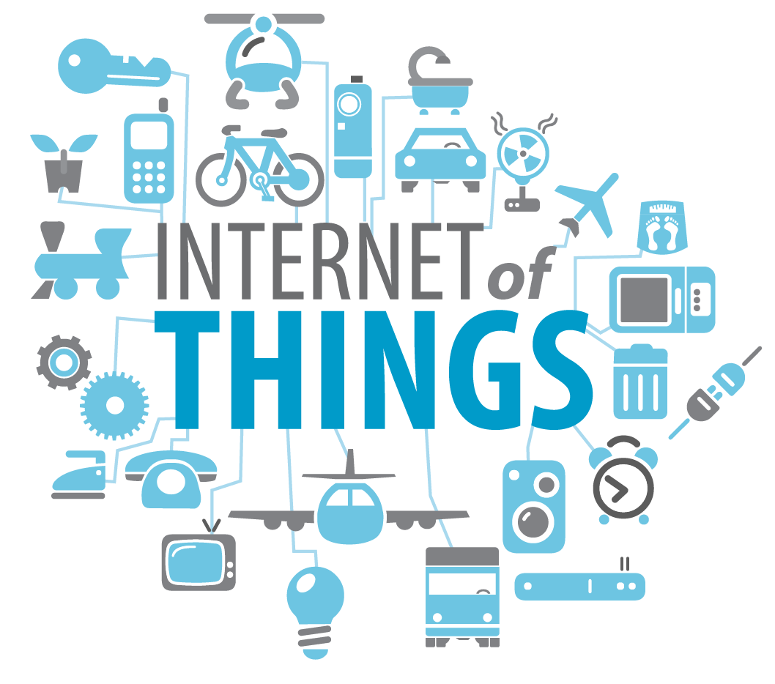

Everything is connected

*Resources*

<https://en.wikipedia.org/wiki/Internet_of_things>

## **Theoretical Questions**

1. Explain the basic architecture of the IoT network.
2. How might Internet Address (IPv6) affect the development and implementation of the Internet of Things?
3. What is the difference between a wireless sensor network (WSN) and the Internet of Things (IoT) network?
4. What are security concerns related to IoT?
5. How might wireless communications have an effect on the development and implementation of the internet of things (IoT)?

## **Cognitive Radio**

A cognitive radio (CR) is a radio that can be programmed and configured dynamically to use the best wireless channels in its vicinity to avoid user interference and congestion. Such a radio automatically detects available channels in wireless spectrum, then accordingly changes its transmission or reception parameters to allow more concurrent wireless communications in a given spectrum band at one location. This process is a form of dynamic spectrum management.

The main functions of cognitive radios are:

* **Power Control:** Power control is usually used for spectrum sharing CR systems to maximize the capacity of secondary users with interference power constraints to protect the primary users.
* **Spectrum sensing:** Detecting unused spectrum and sharing it, without harmful interference to other users; an important requirement of the cognitive-radio network is to sense empty spectrum. Detecting primary users is the most efficient way to detect empty spectrum. Spectrum-sensing techniques may be grouped into three categories:
* **Transmitter detection**: Cognitive radios must have the capability to determine if a signal from a primary transmitter is locally present in a certain spectrum.
* **Wideband spectrum sensing:** refers to spectrum sensing over large spectral bandwidth, typically hundreds of MHz or even several GHz. Since current ADC technology cannot afford the high sampling rate with high resolution, it requires revolutional techniques, e.g., compressive sensing and sub-Nyquist sampling.
  + *Cooperative detection* - Refers to spectrum-sensing methods where information from multiple cognitive-radio users is incorporated for primary-user detection
  + *Interference-based detection*
* **Null-space based CR:** With the aid of multiple antennas, CR detects the null-space of the primary-user and then transmits within the null-space, such that its subsequent transmission causes less interference to the primary-user
* **Spectrum management:** Capturing the best available spectrum to meet user communication requirements, while not creating undue interference to other (primary) users. Cognitive radios should decide on the best spectrum band (of all bands available) to meet quality of service requirements; therefore, spectrum-management functions are required for cognitive radios. Spectrum-management functions are classified as:
  + - *Spectrum analysis*
    - *Spectrum decision*

The practical implementation of spectrum-management functions is a complex and multifaceted issue, since it must address a variety of technical and legal requirements. An example of the former is choosing an appropriate sensing threshold to detect other users, while the latter is exemplified by the need to meet the rules and regulations set out for radio spectrum access in international (ITU radio regulations) and national (telecommunications law) legislation.

*Resources*

<https://en.wikipedia.org/wiki/Cognitive_radio>

<https://www.youtube.com/watch?v=cd3kCPvaXOw&list=PL6wMum5UsYvZVwfeolCSgZumprx0JoDRs&index=4&t=0s>

## **Theoretical Questions**

1. In the last era we witness an exponential growth in the use of wireless transmitting devices, each demands a piece of the spectrum to itself. Currently the spectrum is statically allocated to devices (for example: WiFi gets 2.4GHz and 5GHz while FM broadcasting gets 88MHz-107MHz). It is known that not all devices use the spectrum at all times (periodically silent channels), yet other devices are deprived of much needed spectrum.

Explain how the usage of cognitive radio technology can solve this problem and make much better use of the spectrum resource.

1. Imagine a small public space (for example, a shopping mall) with 3 stores who gives internet service to clients. One is “Coffee Masters” which have a peak of customers at around 10AM. The other is the “Burger Joint” which most of its customers come to eat lunch at around 2PM. The last in the “Cinema Kol-Noa Kino” with the most activity at nighttime from about 9PM.

All stores decided to share the spectrum in order to save money, buying only one allocation from the authorities.

# Part 2 – Build a sensor network

kkctukf